Exercise Ismael Ruiz-Huidobro Arroyo

1. Open “Server Manager” and select “Dashboard” on the left column ->

Welcome to server manager -> Quick start -> 1 Configure this local server -> 2

Add roles and features.

On the “Add Roles and Features Wizard” window -> “Next” -> “Next” -> “Next” ->

“Select server roles”: select “Active Directory Domain Services” -> “Add

Features”-> “Next” -> “Next” -> “Next” -> “Install”. **Screenshot** . Then: “Close”.

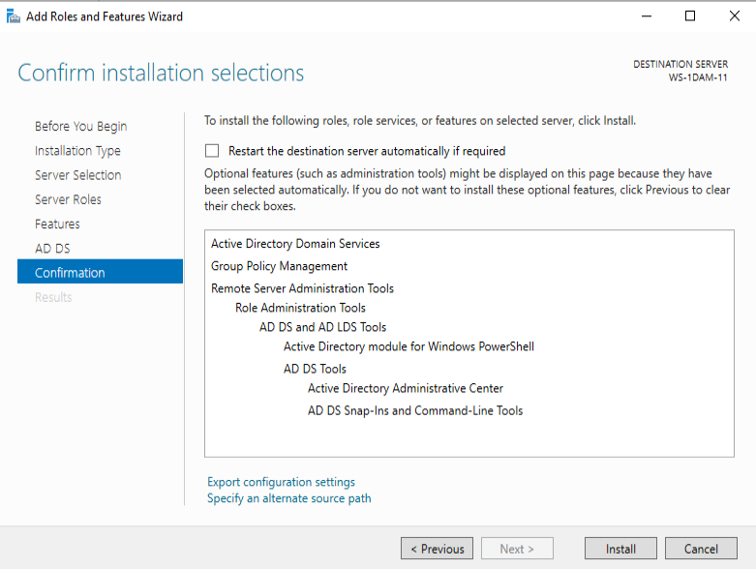

2. After the “Active Directory Domain Services” Role has been installed, restart

the server. Open “Server Manager” and click on the “yellow warning” located in

the flag icon. Then, click on “Promote this server to a domain controller”.

On the “Active Directory Domain Services Configuration Wizard”, on

“Deployment Configuration”, “Select the deployment operation”: choose “Add

a new forest”. On “Root domain name” write: “SI-XY.LOCAL” being XY the last 2

digits of your real computer’s IP (your real computer, not your partner’s real

computer). **Screenshot** . Click “Next”.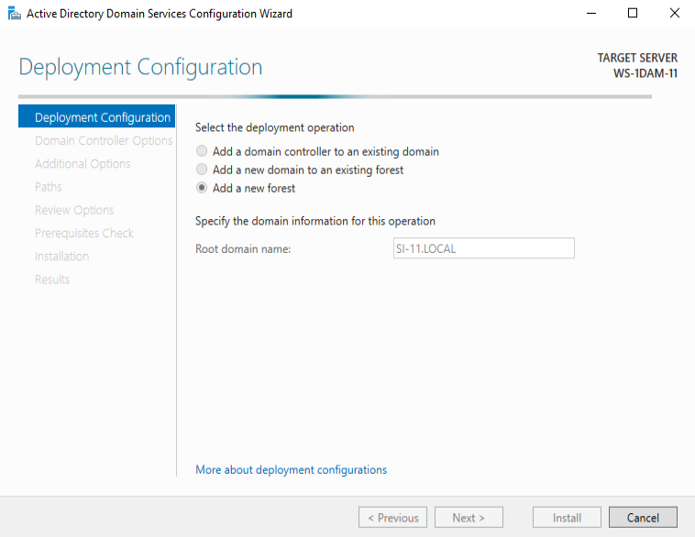

3. On “Domain Controller Options” -> Forest functional level: “Windows Server

2016” -> Domain functional level: “Windows Server 2016”. On “Specify domain

controllers capabilities”: check “Domain Name System (DNS) server”, and

check “Global Catalog (GC)”. For the password, type “Balmis1”. **Screenshot** .

Click “Next”.

On “DNS Options”, DO NOT check “Create DNS delegation”. Click “Next”.

On “Additional Options”, DO NOT change “The NetBIOS domain name”. Click

“Next”.

On “Paths” -> Click “Next”.

On “Review Options” -> Click “Next”.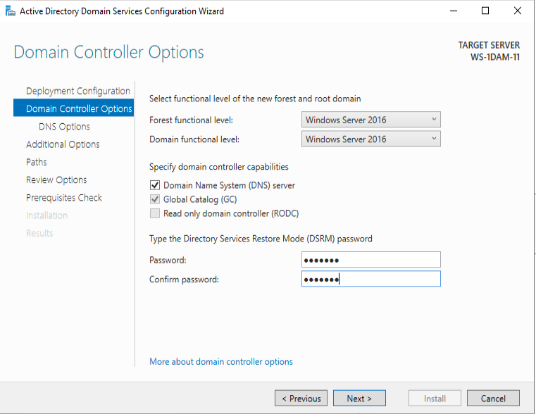

4. On “Prerequisites Check”, after the window loads completely, **screenshot** ->

Click “Install”.

Wait until the “Active Directory Domain Services Configuration Wizard”

finishes the installation.

“You’re about to be signed out” blue window -> Click “Close”.

The server will restart: this can take some minutes. 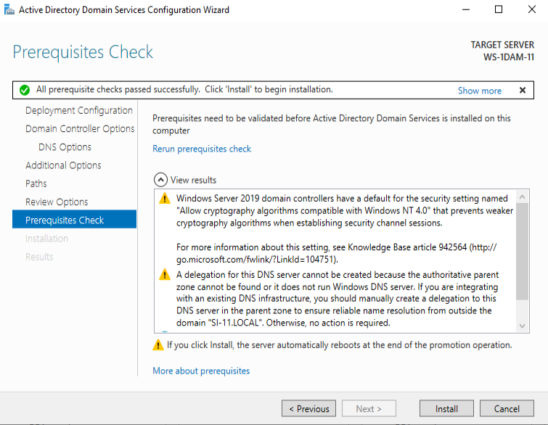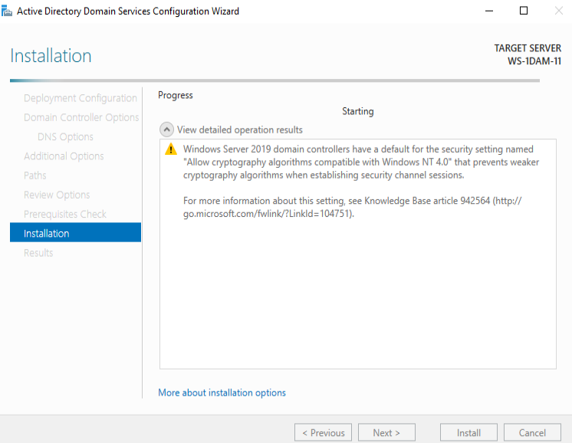

5. After restarting, login with user “NAME-OF-YOUR-DOMAIN\Administrator” and

password “Balmis1”, taking a **screenshot** .

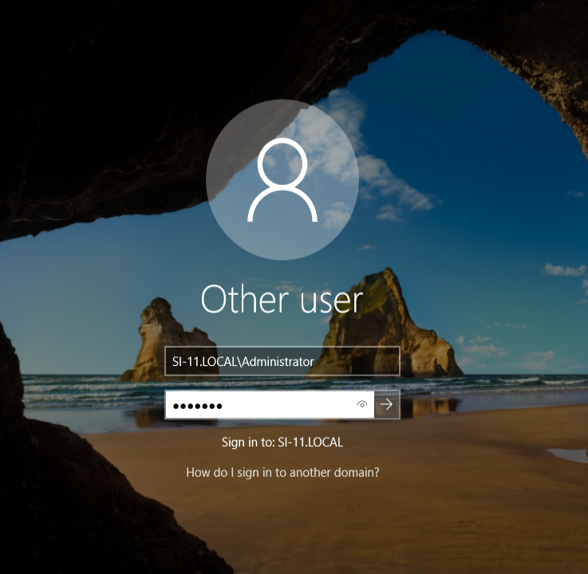

6. Open “Server Manager” and select “Dashboard” on the left column. Scroll

down to “ROLE AND SERVER GROUPS” and check the Roles that you have

installed and running (green color) on your server. Now you should have 2 new

Roles: “AD DS” (Active Directory Domain Services) and “DNS”.

Go the Start button -> Windows Administrative Tools. You should have like 6

new programs named “Active Directory …”, take a **screenshot** .

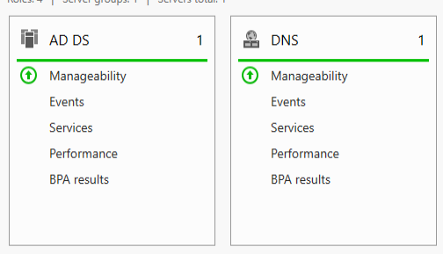

7. Click on “Active Directory Users and Computers” to open this program and

check it out. Now you have installed “Active Directory Domain Services”: you

have a Windows Domain fully functional and your Windows Server is a

Domain Controller. **Screenshot** .

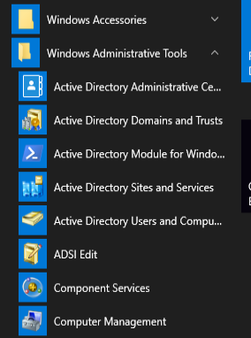

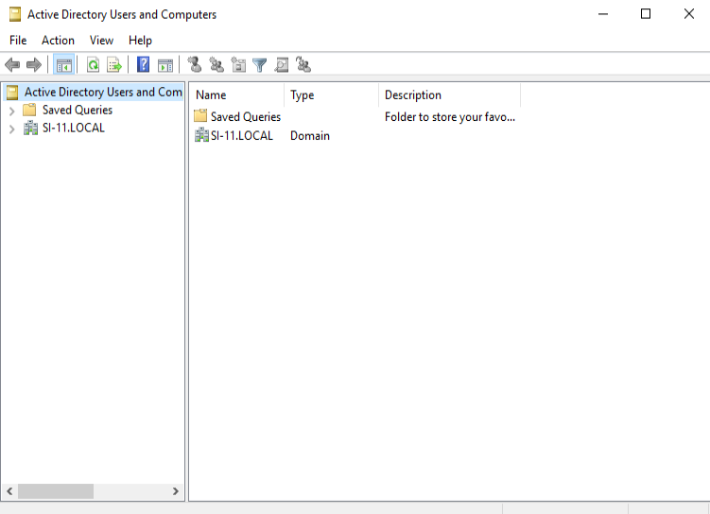

1. Go to the TCP/IP settings, and on “Preferred DNS server”, write the IP of your

Windows Server machine. **Screenshot** .

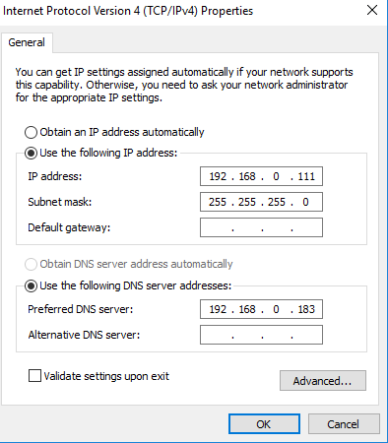

2. Go to “File Explorer” -> “This PC” -> Right click “Properties” -> “Change settings”

-> “Computer name” tab -> “Change” button -> Check “Domain” -> Write:

“NAME-OF-YOUR-DOMAIN”. **Screenshot** .

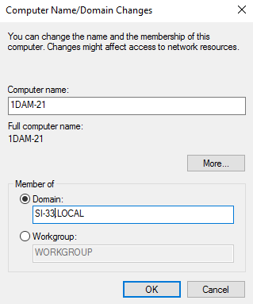

3. It will prompt a window asking for a user with administrative permissions:

write user “Administrator” and password “Balmis1”.

After being welcomed to your domain, restart your Windows 10 (client) virtual

machine.

On the login window, write user “Administrator” and password “Balmis1” and

login to your Windows 10 (client) virtual machine. **Screenshot** .

